A

Project - I Report

On

**EMERGENCY ALARM**

*Submitted in partial fulfillment of the requirements for the award of the degree of*

**Bachelor of Technology**

In

**Information Technology**



(Session 2018-2019)

**Guided By - Submitted by-**

**Mr. Shirish Nagar** **Prachi Gupta(PCE/IT/15/032)**

Assistant Professor **S. Rajshree (PCE/IT/15/047)**

Department of Information Technology **Shaily Rani (PCE/IT/15/049)**

Semester –VII

**DEPARTMENT OF INFORMATION TECHNOLOGY**

**POORNIMA COLLEGE OF ENGINEERING, JAIPUR**

**RAJASTHAN TECHNICAL UNIVERSITY, KOTA**

October, 2018

## Candidate’s Declaration

I/We hereby declare that the work, which is being presented in the **Project - I Report**, titled **Emergency Alarm** in partial fulfillment for the award of degree of **Bachelor of Technology** in **Information Technology**, and submitted to the Department of **Information Technology, Poornima College of Engineering**, **Jaipur** is a record of my own work/investigations carried under the guidance of **Mr. Shirish Nagar**, Department of **Information Technology**, **Poornima College of Engineering.**

I/We have not submitted the matter presented in this Project-I Report anywhere for the award of any other Degree.

(1)Prachi Gupta (PCE/IT/15/032)

(2)S. Rajshree (PCE/IT/15/047)

(3)Shaily Rani (PCE/IT/15/049)

Mr. Shirish Nagar

Assistant Professor

Department Of Information Technology

Date: 31/10/2018

Place: Jaipur



**DEPARTMENT OF INFORMATION TECHNOLOGY**

Date: 31/10/2018

**CERTIFICATE**

This is to certify that **Project - I** report titled **Emergency Alarm** has been submitted by **Prachi Gupta, S.Rajshree, Shaily Rani (PCE15IT032, PCE15IT047, PCE15IT049**) in partial fulfillment for the award of the Degree of **Bachelor of Technology** in **Information Technology** during the session 2018-19, Odd Semester.

The project work is found satisfactory and approved for submission.

**(Mr. Amol Saxena**) **(Mr. Shirish Nagar)**

HOD - IT Project Coordinator - IT

**ACKNOWLEDGEMENT**

We take this opportunity to express our deep sense of gratitude to **Mr. Shirish Nagar, Assistant Professor**, Department of Information Technology, Poornima College of Engineering, and Jaipur for his valuable guidance and cooperation throughout the project work. He provided constant encouragement and unceasing enthusiasm at every stage of the project work and for taking part in useful decision and giving necessary advices and guidance

We express our indebtedness to **Mr. Amol Saxena**, **Head of Department** of Information Technology, Poornima College of Engineering, and Jaipur for providing us an opportunity to present this report.

It gives us immense pleasure in acknowledging the love and encouragement showered on us by our parents. Their financial and moral support helped us to accomplish our work.

I/We perceive this project opportunity as a big milestone in my career development. I will strive to use gained skills and knowledge in the best possible way, and I will continue to work on their improvement, in order to attain desired career objectives.

**Table of Contents**

|  |  |  |  |
| --- | --- | --- | --- |
| **CHAPTER NO.** | **PARTICULARS** | | **PAGE NO.** |
| Title Page | | | i |
| Candidate’s Declaration | | | ii |
| Bonafide Certificate by the Department | | | iii |
| Acknowledgement | | | iv |
| Table of Contents | | | v |
| List of Tables | | | vii |
| List of Figures | | | vii |
| Abstract | | | 1 |
| Chapter 1 | Introduction to the project | | 2-7 |
|  | 1 | About the Project | 2 |
|  | 2 | Purpose and Scope | 2 |
|  | 3 | Working | 3 |
|  | 4 | About Android | 3 |
|  | 5 | Firebase | 7 |
| Chapter 2 | Client survey | | 9 |
| Chapter 3 | Software Requirement Specification (SRS) | | 10-15 |
|  | 1 | Introduction | 10 |
|  | 2 | Functional/Non Functional Requirements | 10 |
|  | 3 | Technical Requirements | 12 |
|  | 4 | System Module | 13 |
|  | 5 | Analysis Diagram | 15 |
| Chapter 4 | Software Design Document( SDD) | | 19-21 |
|  | 1 | Introduction | 19 |
|  | 2 | Architectural Design | 20 |
|  | 3 | UML Diagram | 20 |
|  | 4 | API | 21 |
| Chapter 5 | Test Case Designs | | 25 |
| Chapter 6 | Report from guide and recommendation | | 26 |
| Chapter 7 | Conclusion and Future scope of work | | 27 |
| Chapter 8 | FAQ questions about projects | | 28 |
| References | | | 29 |
| Appendices | | | 30-31 |

**LIST OF TABLES**

|  |  |  |
| --- | --- | --- |
| **TABLE NO.** | **TITLE** | **PAGE NO.** |
| 1 | API | 21 |
| 2 | Test cases | 25 |

**LIST OF FIGURES**

|  |  |  |
| --- | --- | --- |
| **FIGURE NO.** | **TITLE** | **PAGE NO.** |
| 1 | Architecture of Android | 4 |
| 2 | Use Case Diagram | 15 |
| 3 | Sequence Diagram | 16 |
| 4 | Component Diagram | 17 |
| 5 | ER Diagram | 17 |
| 6 | Activity Diagram | 18 |
| 7 | Splash Screen | 22 |
| 8 | Home Screen | 23 |
| 9 | GPS Location | 24 |

**ABSTRACT**

The era of Information technology has become a crucial part of our dynamic life for every human being in the world and usage of smart phones is rising exponentially. Elderly peoples who are unable to provide accurate information and utilize the emergency phone calls, users whom find themselves in an unknown location that can’t be described or provide an accurate address when emergency occurs, casualties which caused by the late arrival of ambulance and searching for an available nearby ambulance have been some of the hustling factor that faced by current fast pace community. With more congested roads and insufficient information, the search and rescue operation become nearly impossible.

Emergency alarm is an android application generally designed for overcoming the problems caused due to unavailability of ambulance at the time of accidents. This application helps us in a way that whenever any accident occurs, we just need to connect to our application and it will send notification to hospitals in a range of 1-3 km and hospital will appoint ambulance on the basis of First Come First Serve with one backup. The hospital will also get the details of the victim like his/her name, blood group, address (if available). According to the details provided by the victim side, the ambulance sent by the hospital will have those basic hospitality facilities necessary for that victim. The system will also have one backup facility. Additional details may be provided to inform the hospital to make necessary arrangements before arrival of the patient.

**CHAPTER 1**

**INTRODUCTION TO PROJECT**

1. **About the Project**

Emergency Response Application is an android mobile application designed for overcoming the problems caused due to unavailability of ambulance at the time of accidents. This application aims to help in a way that whenever any road accident/ emergency occurs, we can connect to the nearby hospitals by sending a request. Application will send notification to hospitals in a range of 1-3 km from the spot of accident and on the basis of First Come First Serve a hospital will be selected. That hospital will appoint an ambulance with one backup.

The hospital will also get the details of the victim like his/her name, blood group, address (if possible). Additional details may be provided to inform the hospital to make necessary arrangements before arrival of the patient.

1. **Purpose and Scope**

Purpose of making this project is to overcome the problem of unavailability of ambulance caused at the time of accidents. Also victim will get a faster hospitality service according to his/her requirement.

1. **Working**

* The demand for Ambulance during any emergency is far outstripping supply, especially in the case when any accident occurs, and it is becoming increasingly difficult to meet this exponential growth in demand. An ambulance can provide vital assistance, transporting the critically injured to the nearest hospital.
* The application will work in such a way that if any accident occurs, the person who is attending that victim will connect to this application by turning his/her GPS location ON. Then the GPS will search the hospitals in a range of 1-3kms.
* The hospital which will be nearest to the victim’s location will get the notification along with the details of the victim like blood group, name, address and mobile number (if available).
* According to the details mentioned of the victim in the application, the hospital will appoint ambulance along with the backup because in case if the first ambulance is unable to reach to that location timely, the other will reach.
* That ambulance will contain basic hospitality facilities which will be required for the victim during his journey to the hospital.
* The hospital will share the details of driver of the ambulances along with their vehicle numbers.
* The attendant of the victim will be able to trace the location of the ambulance using GPS.
* A weekly report will be generated on the basis of number of accidents occurred on some specific places, which will give the outcome that those specific places are much more accident prone.
* That report will be sent to the Municipality Corporation, so that they can further investigate and find out the reasons of the occurrence of accidents in that area.
* Then they will take some preventive steps and this will result in the reduction of number of accidents occurring in a wider scale.

1. **About Android**

Android is a software stack for mobile devices that includes an operating system, middleware and key applications. Android is a software platform and operating system for mobile devices based on the Linux operating system and developed by Google and the Open Handset Alliance. It allows developers to write managed code in a Java-like language that utilizes Google-developed Java libraries, but does not support programs developed in native code. The unveiling of the Android platform on 5th November 2007 was announced with the founding of the Open Handset Alliance, a consortium of 34 hardware, software and telecom companies devoted to advancing open standards for mobile devices. When released in 2008, most of the Android platform will be made available under the Apache free-software and open-source license.

The Open Handset Alliance, a consortium of several companies which include Google, HTC, Intel, Motorola, Qualcomm, T-Mobile, Sprint Nextel and NVIDIA, was unveiled with the goal to develop open standards for mobile devices. Along with the formation of the Open Handset Alliance, the OHA also unveiled their first product, Android, an open source mobile device platform based on the Linux operating system.

Android application development is the development of the dynamic & static android application. It includes Mobile application UI development, Java programming. As firebase has been launched by Google recently application, APIs integration and application maintenance can be done on firebase. Training included UI development of android application, programming & its maintenance through firebase.

* 1. **Architecture**

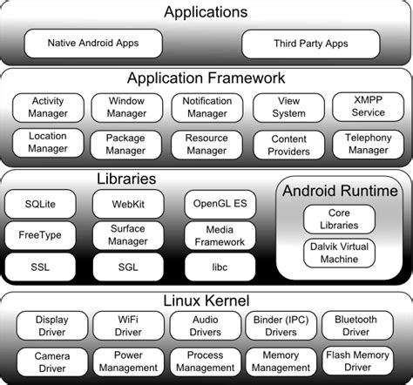

Fig1: Architecture of Android

[Courtesy: Techotopia]

**4.1.1 Linux Kernel**

Android relies on Linux version 2.6 for core system services such as security, memory management, process management, and network stack & driver model. The kernel also acts as an abstraction layer between the hardware & the rest of the software stack. It helps to manage security, memory management, process management, network stack & other important issues. Therefore, the user should bring Linux in his mobile device as the main operating system and install all the drivers required to run it.

**4.1.2 Android Runtime**

At the same level there is Android Runtime, where the main component Dalvik Virtual Machine is located. It was designed specifically for android running in limited environment, where the limited battery, CPU, memory, data storage is the main issues. Android gives an integrated tool which converts generated byte code from jar to decks file. After this byte code becomes more efficient to run on the small process.

**4.1.3 Application Framework**

After that, there is Application Framework, written in Java language. It is a toolkit that all applications use, ones which come with mobile device like Contacts or SMS box, or applications written by Google and any Android developer. It has several components. The Activity Manager manages the life circle of the applications and providesa common navigation back stack for applications, which are running in different processes. The Package Manager keeps track of the applications, which are installed in the device. The Windows Manager is Java programming language abstraction on the top of lower level services that are provided by the Surface Manager.

**4.1.4 Application Layer**

At the top of Android Architecture, we have all the applications, which are used by the final user. By installing different applications, the user can turn his mobile phone into the unique, optimized and smart mobile phone. All applications are written using the Java programming language.

**4.1.5 Android SDK**

Android development starts with the Android SDK. While there are many different programming languages and a host of IDEs (Integrated Development Environments) you can use to create an app, the SDK is a constant.

SDK stands for ‘Software Development Kit’, and essentially provides a selection of tools required to build Android apps or to ensure the process goes as smoothly as possible. Whether you end up creating an app with Java, Kotlin or C#, you need the SDK to get it to run on an Android device and access unique features of the OS.

The Android SDK can be broken down into several components. These include:

* **Platform-tools**: - The Platform-tools are more specifically suited to the version of Android that you want to target. Generally, it is best to install the latest Platform-tools which are also what will be installed by default. After first install though, you need to keep your Platform-tools constantly updated. The tools should be backwards compatible, meaning that you will still be able to support older versions of Android.
* **Build-tools**: - The Build-tools were once categorized under the same heading as the Platform-tools but have since been decoupled so that they can be updated separately. As the name suggests, these are also needed to build your Android apps. This includes the zip align tool for instance, which optimizes the app to use minimal memory when running prior to generating the final APK, and the APK signer which signs the APK (surprise!) for subsequent verification.
* **SDK-tools**: - Arguably the most important parts of this package are in the SDK-tools. You will need these tools regardless of which version of Android you are targeting and these are what will actually create the APK – turning your Java program into an Android app that can be launched on a phone. These include a number of build tools, debugging tools and image tools. An example is DDMS, which is what lets us use the Android Device Monitor to check the status of an Android device.
* **The Android Debug Bridge (ADB):** - The Android Debug Bridge (ADB) is a program that allows you to communicate with any Android device. It relies on Platform-tools in order to understand the Android version that is being used on said device and hence it is included in the Platform-tools package. You can use ADB to access shell tools such as log cat, to query your device ID or even to install apps.
* **Android Emulator**: - The Android emulator is what lets you test and monitor apps on a PC, without necessarily needing to have a device available. To use this, you also get an Android system image designed to run on PC hardware. You’ll use the ‘Android Virtual Device’ manager in order to choose which version of Android you want to emulate, along with the device specifications (screen size, performance etc.)

1. **FIREBASE**

Firebase is a mobile and web app development platform that provides developers with a plethora of tools and services to help them develop high-quality apps, grow their user base, and earn more profit.

Firebase Services are:

**5.1 Real-time Database**

The Firebase Real-time Database is a cloud-hosted No SQL database that lets you store and sync between your users in real time. The Real-time Database is really just one big JSON object that the developers can manage in real time. Real-time syncing makes it easy for your users to access their data from any device, be it web or mobile. Real-time Database also helps your users collaborate with one another. Another amazing benefit of Real-time Database is that it ships with mobile and web SDKs, allowing you to build your apps without the need for servers. When your users go offline, the Real-time Database SDKs use local cache on the device to serve and store changes. When the device comes online, the local data is automatically synchronized. The Real-time Database can also integrate with Firebase Authentication to provide a simple and intuitive authentication process.

* 1. **Authentication**

Firebase Authentication provides backend services, easy-to-use SDKs, and ready-made UI libraries to authenticate users to your app. Normally, it would take you months to set up your own authentication system. And even after that, you would need to keep a dedicated team to maintain that system. But if you use Firebase, you can set up the entire system in under 10 lines of code that will handle everything for you, including complex operations like account merging.

**CHAPTER 2**

**CLIENT SURVEY**

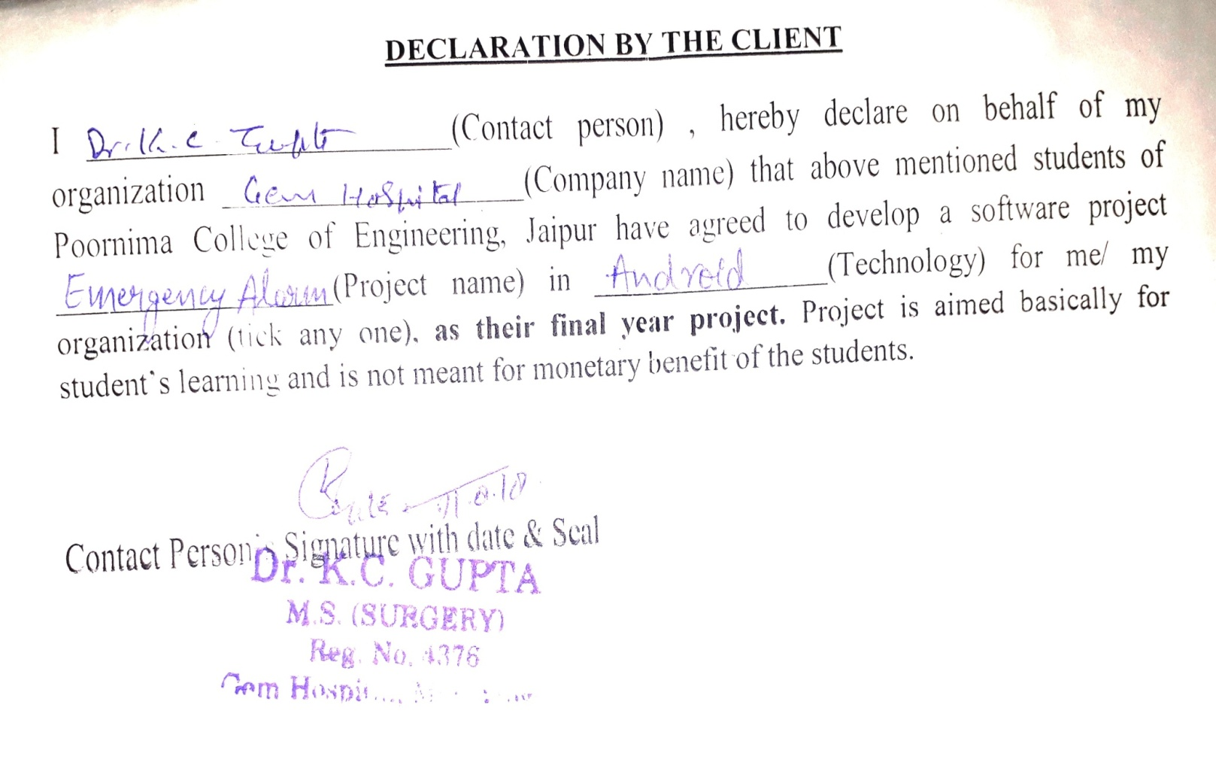

**CHAPTER 3**

**Software Requirement Specification**

# Introduction

## Purpose

Emergency alarm is an android application generally designed for overcoming the problems caused due to unavailability of ambulance at the time of accidents. This application helps us in a way that whenever any accident occurs, we just need to connect to our application and it will send notification to hospitals in a range of 1-3 km and hospital will appoint ambulance on the basis of First Come First Serve with one backup. The hospital will also get the details of the victim like his/her name, blood group, address (if available). According to the details provided by the victim side, the ambulance sent by the hospital will have those basic hospitality facilities necessary for that victim. The application will work in such a way that if any accident occurs, the person who is attending that victim will connect to this application by turning his/her GPS location ON. Then the GPS will search the hospitals in a range of 1-3kms.

* 1. **Feasibility**
* This will provide faster service of ambulance.
* Early medical hospitality providence.
* Reduction of number of accidents through the preventive measures taken by the municipality corporation on the basis of weekly report generated by this application.

1. **Functional /Nonfunctional Requirements**
   1. **Functional Requirements**

* A system for helping victim by making an emergency call.
* One can just tap on the button provided in the app to make emergency call.
* The facility to see nearest hospital.
* Hospital is selected on the basis of FCFS.
* The facility with one backup ambulance.
* Details of driver and its location is shared by the hospital.
* Daily report of accidents is sent to Municipal Corporation.

## 2.2 Nonfunctional Requirements

## Performance Requirements

The system is expected to response in a short time. There is also a backup facility of ambulance. Moreover, nearest hospitals are given first priority.

## Safety Requirements

Details shared by the attendant of that victim will be kept secret and will be secured so that no misuse takes place.

## Security Requirements

1. Secure access of data of patient.

2. 24x7 availability.

3. Flexible service based architecture will be highly desirable for future extension.

## Software Quality Attributes

## **Usability** The application is developed with a user friendly environment such as the font size, text alignment and other complicated things are adjusted in a simple way. User can easily understand the functions of the application.

##### **Reliability:** System will be able to perform operation efficiently with a reliable environment and with minimum chances of losing data.

##### **Supportability:** This application can be easily downloaded from Google play store and can be used rapidly in case of emergency.

## 3. Technical Requirments ( Hardware /Software)

## 3.1 Operating Environment

Our application will require android operating system and the details will be stored in the database naming Firebase Database. All this runs effectively with Internet connectivity as it is an Android application and it will use GPS facility to trace both the ambulance and victim’s position.

## 3.2 Hardware Interfaces

* GPS is required for tracking the location of victim and driver.
* 24*7 Internet connectivity

## 3.3 Software Interfaces

* Languages Used to implement : JAVA
* Operating System: Android
* Internet Browser: Mozilla/Google chrome
* Front End: Xml
* Back End: Java
* Database: Firebase
* Tool: Android studio

## 3.4 Communications Interfaces

* The application will contain a form which will be filled by the attendant of the victim. This form will contain the basic information of the victim like his/her name, address, phone number and blood group.
* A textbox will be displayed which will contain the information of the ambulance and it is driver and it will be shared by the hospital to our application.

# SYSTEM FEATURES

## Module 1: User

* + 1. **Description and Priority**

User can be anyone, it may be the attendant of the victim or it may be victim itself. It is of Medium priority as the user will be the main asset of this application. This application is beneficial for them as they won’t be waiting for a long time for ambulance when they entertain any victim.

* + 1. **Stimulus/Response Sequences**

User will be able to make an emergency call to various hospitals using this application. Also with the help of this application he will be able to trace the location of the ambulance along with the details of the driver.

## Module 2: Application

* + 1. **Description and Priority**

Application is the main key connecting users with the hospitals at ease. It is of the highest priority as everything is happening with it is help only.

* + 1. **Stimulus/Response Sequences**

Application will search all the nearby hospitals which will be in the range of 1-3kms from the victim’s location and will send the notification to them. It will receive the information of the driver and the ambulance number. That ambulance could be tracked using the GPS by the user. Also at the end of each week, it will generate a report which will contain the information regarding the number of accidents which took place during that week and at what-what places accidents took place.

## Module 3: Hospital

* + 1. **Description and Priority**

Hospitals will be the second last step of all the process. They will provide the hostage and treatment to the victims.

* + 1. **Stimulus/Response Sequences**

Hospital which will be the nearest to the victim’s location will accept the request and will quickly share the details of the ambulance and it’s driver with the application, and will send the ambulance which will contain the basic hospitality materials required for the victim.

## Module 4: Municipality Corporation

* + 1. **Description and Priority**

Municipality Corporation will be the last factor of this project. It has the least priority amongst all.

* + 1. **Stimulus/Response Sequences**

On the basis of the weekly report generated by the application the municipality corporation will go through the places at which maximum number of accidents took place. And will take some preventive measures to overcome all the causes of accidents at those places. This will result in the reduction of the accidents and many lives will be saved.

1. **Analysis Diagram**
2. **Use case Diagram**

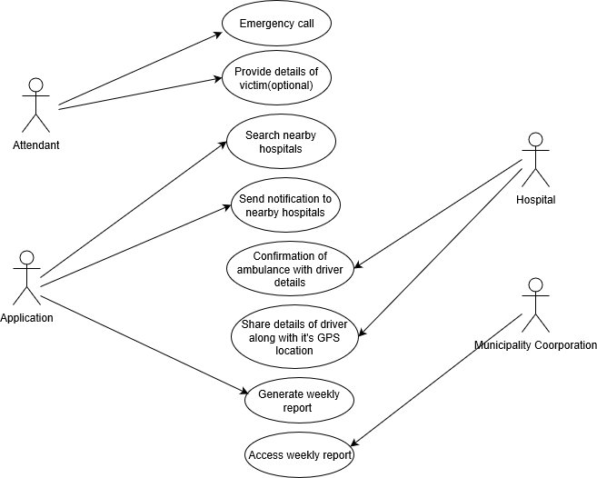

Fig2: Use case

1. **Sequence Diagram**

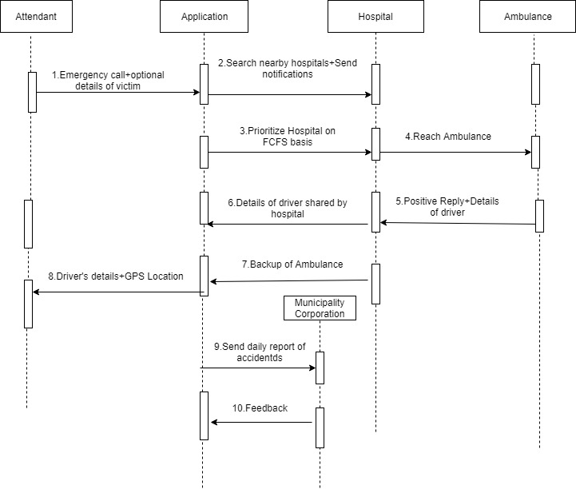

Fig3: Sequence Diagram

1. **Component Diagram**

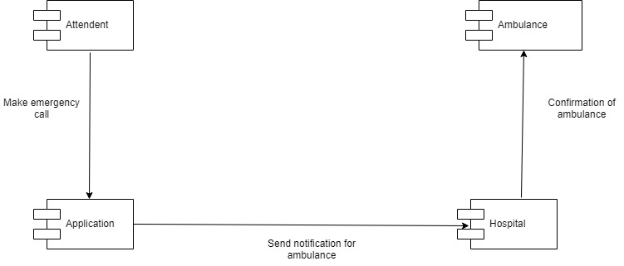

Fig4: Component Diagram

1. **ER Diagram**

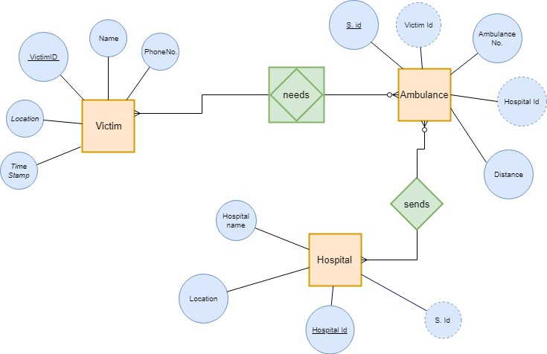

Fig5: ERD

1. **Activity Diagram**

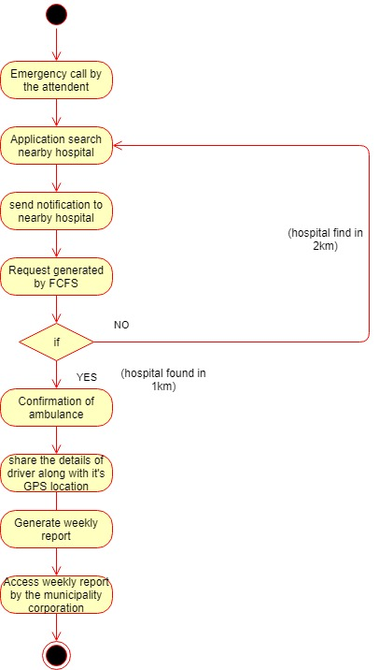

Fig6: Activity Diagram

**CHAPTER 4**

**SOFTWARE DESIGN DOCUMENT**

1. **INTRODUCTION**

Emergency Response Application is an android application generally designed for overcoming the problems caused due to unavailability of ambulance at the time of accidents. This application helps us in a way that whenever any accident occurs, we just need to connect to our application and it will send notification to hospitals in a range of 1-3 km and hospital will appoint ambulance on the basis of First Come First Serve with one backup. The hospital will also get the details of the victim like his/her name, blood group, address (if available). According to the details provided by the victim side, the ambulance sent by the hospital will have those basic hospitality facilities necessary for that victim.

**1.1 WORKING**

* The demand for Ambulance during any emergency is far outstripping supply, especially in the case when any accident occurs, and it is becoming increasingly difficult to meet this exponential growth in demand. An ambulance can provide vital assistance, transporting the critically injured to the nearest hospital.
* The application will work in such a way that if any accident occurs, the person who is attending that victim will connect to this application by turning his/her GPS location ON. Then the GPS will search the hospitals in a range of 1-3kms.
* The hospital which will be nearest to the victim’s location will get the notification along with the details of the victim like blood group, name, address and mobile number (if available).
* According to the details mentioned of the victim in the application, the hospital will appoint ambulance along with the backup because in case if the first ambulance is unable to reach to that location timely, the other will reach.
* That ambulance will contain basic hospitality facilities which will be required for the victim during his journey to the hospital.
* The hospital will share the details of driver of the ambulances along with their vehicle numbers.
* The attendant of the victim will be able to trace the location of the ambulance using GPS.
* A weekly report will be generated on the basis of number of accidents occurred on some specific places, which will give the outcome that those specific places are much more accident prone.
* That report will be sent to the Municipality Corporation, so that they can further investigate and find out the reasons of the occurrence of accidents in that area.
* Then they will take some preventive steps and this will result in the reduction of number of accidents occurring in a wider scale.

1. **Architectural Design (System Flow Chart)**

Requirement analysis and planning

Problem

Analysis

A

Identifying Solution

Optimization of Problem

Source code development

Practical Implementation

System design

1. **UML Diagram**

Same as Section 5 in Chapter-3

1. **API (Application Program Interface)**

|  |  |  |  |  |
| --- | --- | --- | --- | --- |
| **S. No** | **Class / Library** | **Function** | **Arguments (& Data types)** | **Description of the functionality** |
| 1 | SphericalUtil | Distance Between | (int coord1, int coord2) | Calculates Euclidean distance between two coordinates passed as integer arguments |
| 2 | Location | onMapReady | (GoogleMap, googleMap) | Represents Geographic location returned at a particular time |
| 3 | AnimationsUtil | loadAnimation | (Context context, int id) | Loads an animation object from a resource |
| 4 | LatLng | LatLng | (double latitude, double longitude) | Constructs a LatLng with the given latitude and longitude, measured in degrees |

**Table no: 1**

1. **GUI Design**

* **Splash Screen**

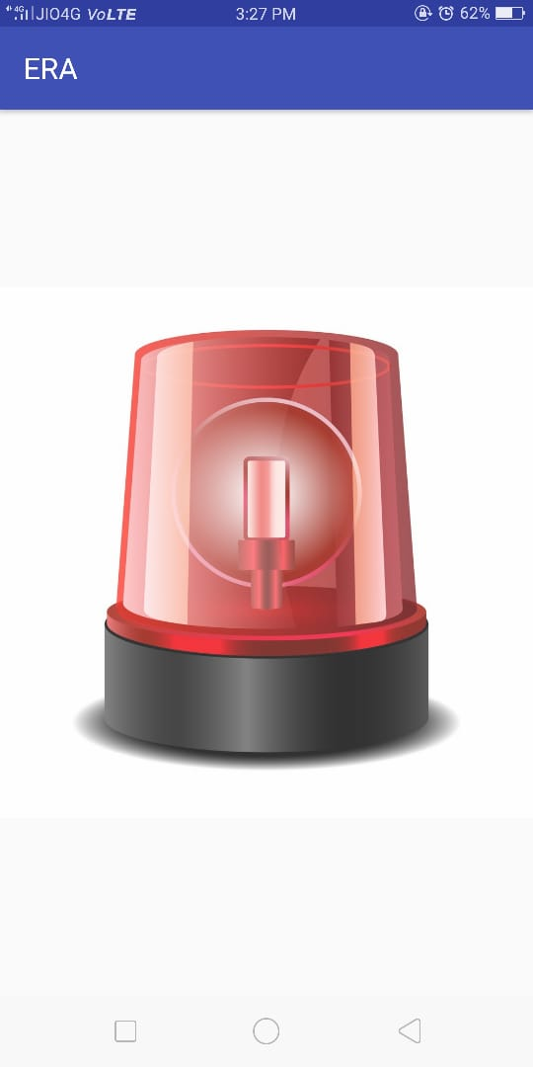

Fig7: Splash Screen

* **Home Page**

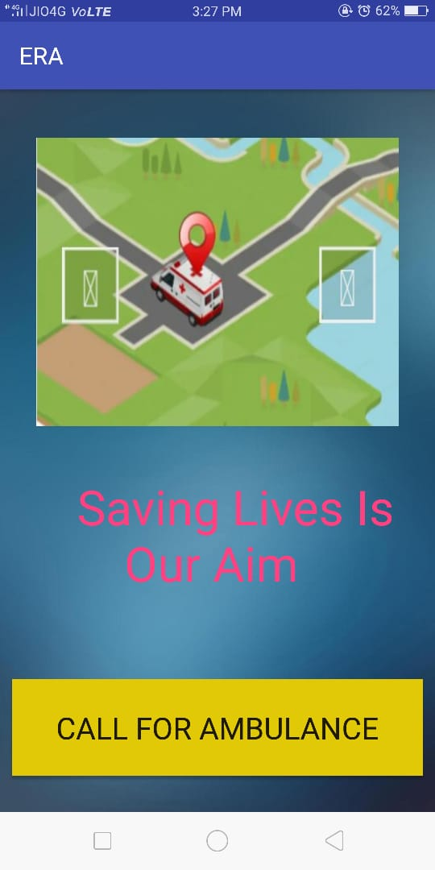

Fig8: Home Page

* **GPS Location**

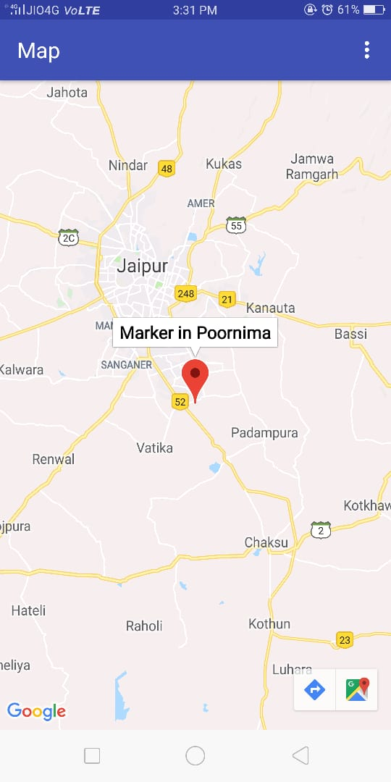

Fig9: GPS

**CHAPTER 5**

**TEST CASES**

|  |  |  |
| --- | --- | --- |
| **Step No.** | **Step Description** | **Result** |
| 1 | Mobile location needs to be turned on for tracking victim’s location | It will fail if location of device is not on |
| 2 | Application works for Jaipur place only | It will not respond for other cities other than Jaipur. |

**Table no: 2**

**CHAPTER-6**

**REPORT FROM GUIDE**

**CHAPTER-7**

**CONCLUSION AND FUTURE SCOPE**

It was a wonderful and learning experience while working on this project. This project took us through the various phases of project development and gave me a real insight into the world of software engineering. The joy of working and thrill involved while tackling the problems and challenges gave us a feel of developers industry.

It was due to this project we came to know how professional software’s are designed.

We enjoyed each and every bit of work we had put into this project.

Lessons learned & Skills developed:-

* Ability to acquire and apply fundamental principles of science and engineering.
* Capability to communicate effectively.
* Ability to identify, formulate and model problems and field engineering solutions based on a system approach.
* Understanding of the importance of sustainability and cost- effectiveness in design and development of engineering solution.
* Ability to be a multi- skilled engineer with goods technical knowledge, management,

Leadership skills.

* Awareness of the social, culture, global and environmental responsibility as an engineer.
* Capability and enthusiasm for self-improvement through continuous professional development and life-long learning.

**FUTURE SCOPE**

* Application can be used to reduce the fatal outcomes caused due to the unavailability of ambulance services at the right time.
* Application can be developed highly efficient and can be used anytime.
* Reports generated can be used as a milestone to reduce the number of accidents.

**CHAPTER-8**

**FAQ ABOUT PROJECT**

1. What is the application of your project?
2. What are the functional and non functional requirements of your project?
3. What is the future scope of your project?
4. What are the technologies used in your project?
5. How does GPS work in your project?
6. What are the criteria of selection of hospital by the application?

**REFERENCES**

* [**https://bohatala.com/ambulance-management-system/**](https://bohatala.com/ambulance-management-system/)
* [**https://timesofindia.indiatimes.com**](https://timesofindia.indiatimes.com/)
* [**https://irjet.net/archives/V4/i10/IRJET-V4I10148.pdf**](https://irjet.net/archives/V4/i10/IRJET-V4I10148.pdf)
* [**https://www.hindustantimes.com/jaipur/deaths-in-road-accidents-down-in-rajasthan/story-ljaXpRDekyxo885dN1NYpO.html**](https://www.hindustantimes.com/jaipur/deaths-in-road-accidents-down-in-rajasthan/story-ljaXpRDekyxo885dN1NYpO.html)
* **Coding with mitch (YouTube Channel)**
* [**https://developer.android.com**](https://developer.android.com/)

**APPENDICES**

1. **Android Version**

We have used Android Studio 3.1 for making our application.

1. **Firebase**

Firebase can be divided into :-

1. Develop: It includes :
2. Realtime Database
3. Auth
4. Cloud Functions
5. Hosting
6. Perfomance Monitoring
7. Grow: It includes :
8. Firebase Analytics
9. Remote Configuration
10. AdMob
11. Dynamic Links
12. Cloud Messaging
13. **Distance Calculation**

Calculate distances, areas and headings via spherical geometry, using the spherical geometry utilities in SphericalUtil, we compute distances, areas, and headings based on latitudes and longitudes. Here are some of the methods available in the utility:

* computeDistanceBetween() – Returns the distance, in meters, between two latitude/longitude coordinates.
* computeHeading() – Returns the bearing, in degrees, between two latitude/longitude coordinates.
* computeArea() – Returns the area, in square meters, of a closed path on the Earth.
* interpolate() – Returns the latitude/longitude coordinates of a point that lies a given fraction of the distance between two given points. We can use this to animate a marker between two points, for example.